**NAME : MADHANKUMAR N**

**ROLL NO : 727722EUIT510**

**CA TEST 1**

**Q.NO 1**

**TASK 1 : ADD TO CART**

**CODE:**

**package** com.selenium.test2.selenium1;

**import** org.openqa.selenium.By;

**import** org.openqa.selenium.WebDriver;

**import** org.openqa.selenium.chrome.ChromeDriver;

**import** org.openqa.selenium.chrome.ChromeOptions;

**import** io.github.bonigarcia.wdm.WebDriverManager;

**public** **class** CA1_Q1

{

**public** **static** **void** main( String[] args ) **throws** InterruptedException

{

WebDriverManager.*chromedriver*().setup();

ChromeOptions co=**new** ChromeOptions();

co.addArguments("--remote-allow-origins=*");

WebDriver driver=**new** ChromeDriver(co);

driver.manage().window().maximize();

driver.get("https://www.amazon.in/gp/product/B09FXM3WDR/ref=ox_sc_act_title_1?smid=A14CZOWI0VEHLG&psc=1");

driver.findElement(By.*id*("add-to-cart-button")).submit();

String cartTitle = driver.getTitle();

System.***out***.println(cartTitle);

**if** (cartTitle.equals("Amazon.in Shopping Cart")) {

System.***out***.println("Item is in the Cart");

} **else** {

System.***out***.println("Item is NOT in the Cart");

}

}

}

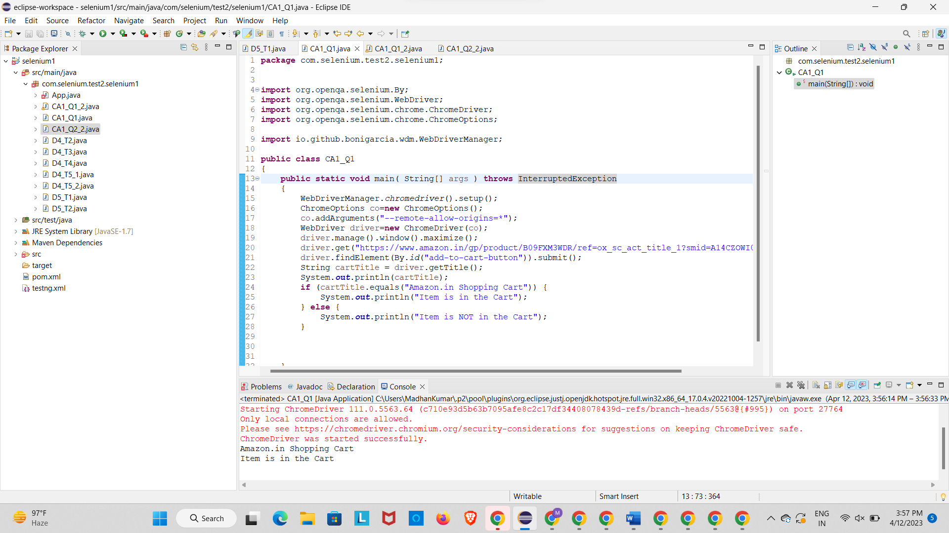

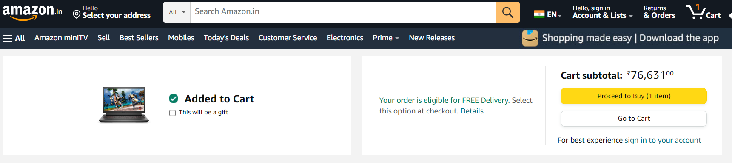

**TASK 2 : REMOVE FROM CART**

**CODE :**

**package** com.selenium.test2.selenium1;

**import** org.openqa.selenium.By;

**import** org.openqa.selenium.WebDriver;

**import** org.openqa.selenium.WebElement;

**import** org.openqa.selenium.chrome.ChromeDriver;

**import** org.openqa.selenium.chrome.ChromeOptions;

**import** io.github.bonigarcia.wdm.WebDriverManager;

**public** **class** CA1_Q1_2

{

**public** **static** **void** main( String[] args ) **throws** InterruptedException

{

WebDriverManager.*chromedriver*().setup();

ChromeOptions co=**new** ChromeOptions();

co.addArguments("--remote-allow-origins=*");

WebDriver driver=**new** ChromeDriver(co);

driver.manage().window().maximize();

driver.get("https://www.amazon.in/gp/product/B09FXM3WDR/ref=ox_sc_act_title_1?smid=A14CZOWI0VEHLG&psc=1");

driver.findElement(By.*id*("add-to-cart-button")).submit();

driver.get("https://www.amazon.in/gp/cart/view.html?ref_=nav_cart");

driver.findElement(By.*cssSelector*("[value='Delete']")).click();

String t=driver.getTitle();

System.***out***.println(t);

}

}

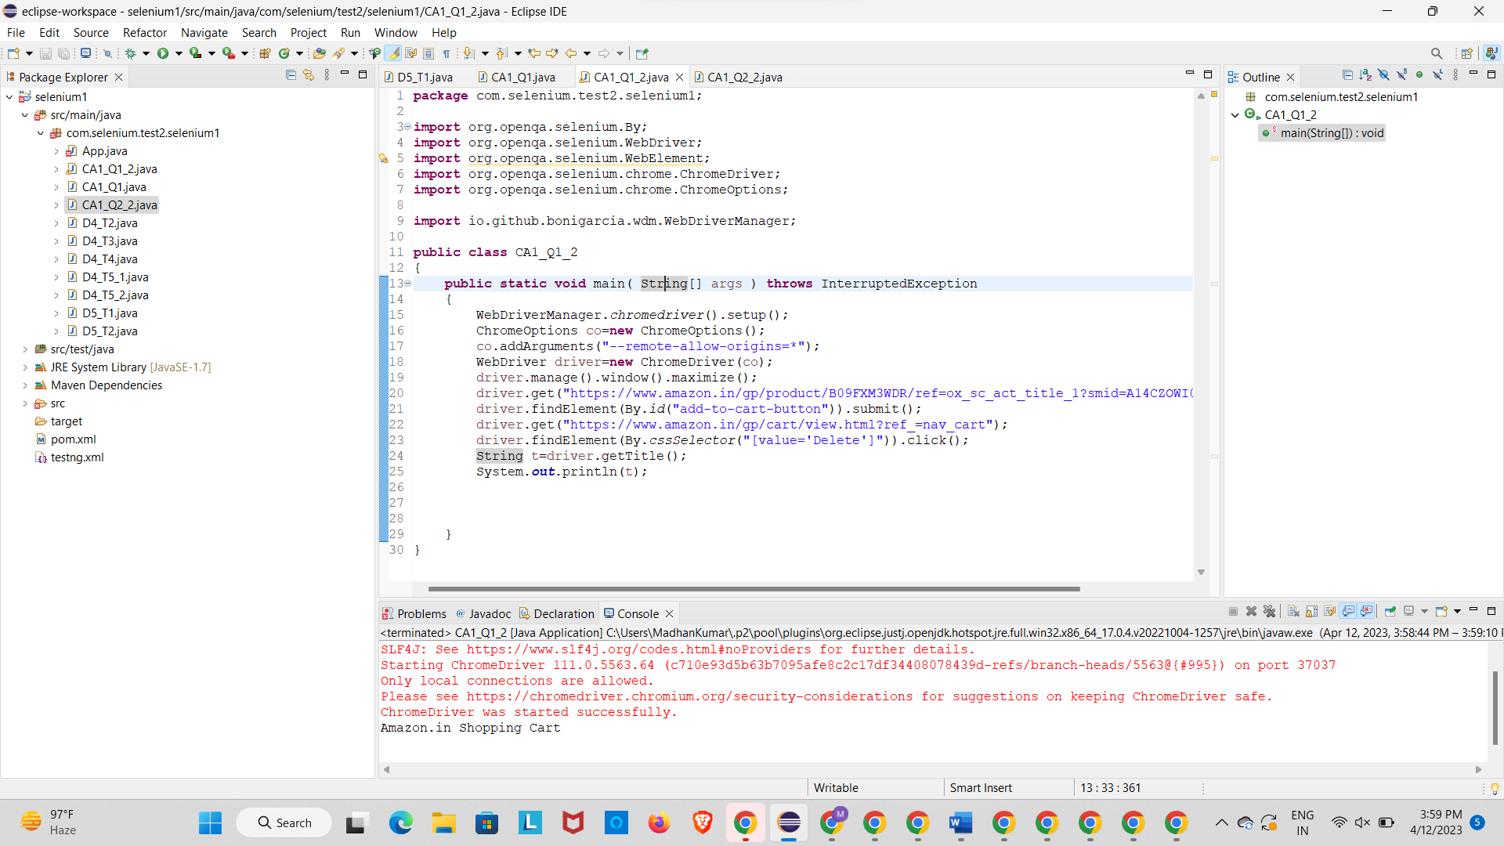

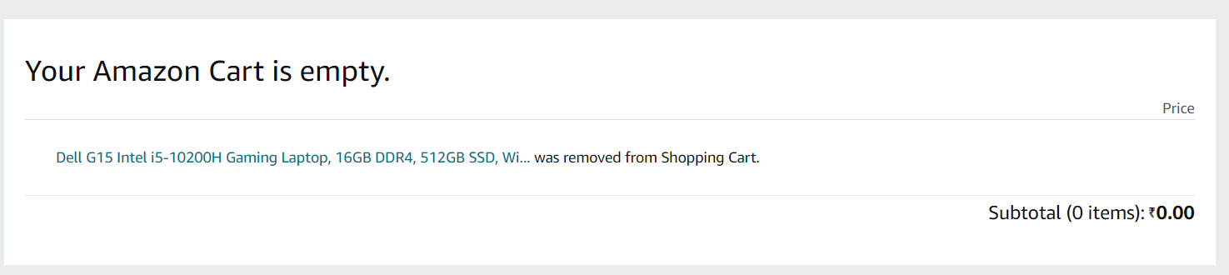

**TASK 3 : UPDATE**

**CODE :**

**package** com.selenium.test2.selenium1;

**import** java.util.List;

**import** org.openqa.selenium.By;

**import** org.openqa.selenium.JavascriptExecutor;

**import** org.openqa.selenium.WebDriver;

**import** org.openqa.selenium.WebElement;

**import** org.openqa.selenium.chrome.ChromeDriver;

**import** org.openqa.selenium.chrome.ChromeOptions;

**import** org.openqa.selenium.edge.EdgeDriver;

**import** org.openqa.selenium.interactions.Actions;

**import** org.openqa.selenium.support.ui.Select;

**import** dev.failsafe.internal.util.Assert;

**import** io.github.bonigarcia.wdm.WebDriverManager;

**public** **class** CA1_Q1_3 {

**public** **static** **void** main( String[] args ) **throws** InterruptedException

{

WebDriverManager.*chromedriver*().setup();

ChromeOptions co=**new** ChromeOptions();

co.addArguments("--remote-allow-origins=*");

WebDriver driver=**new** ChromeDriver(co);

driver.manage().window().maximize();

driver.get("https://www.amazon.in/Anne-Diamond-Analog-Womens-Watch-AK3686BKGB/dp/B0968Q7L3M/ref=sr_1_1_sspa?crid=293FS4VHUVN6K&keywords=watches&qid=1681287782&sprefix=watches%2Caps%2C323&sr=8-1-spons&sp_csd=d2lkZ2V0TmFtZT1zcF9hdGY&psc=1");

driver.findElement(By.*id*("add-to-cart-button")).submit();

String t=driver.getTitle();

System.***out***.println(t);

String cart=driver.findElement(By.*xpath*("//*[@id=\"NATC_SMART_WAGON_CONF_MSG_SUCCESS\"]/span")).getText();

**if**(cart.equals("Added to cart"));

System.***out***.println("1. Verified that Product added to cart ");

driver.navigate().back();

WebElement sort1=driver.findElement(By.*xpath*("//*[@id=\"quantity\"]"));

sort1.click();

Select select=**new** Select(sort1);

select.selectByIndex(1);

String drop=driver.findElement(By.*xpath*("//*[@id=\"quantity\"]")).getText();

**if**(drop.equals("2"));

System.***out***.println("3. Verified that Product is updated to cart ");

}

}

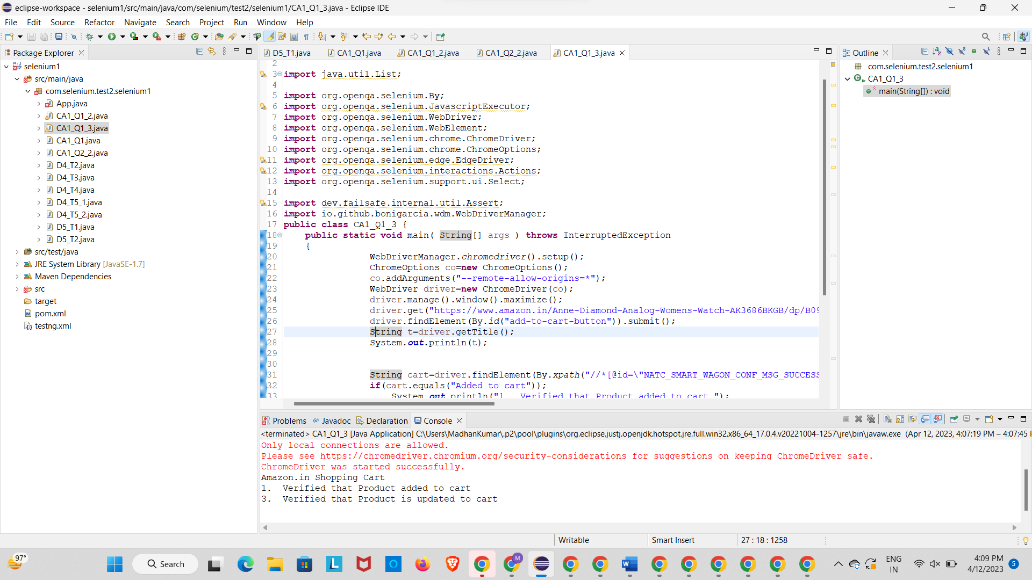

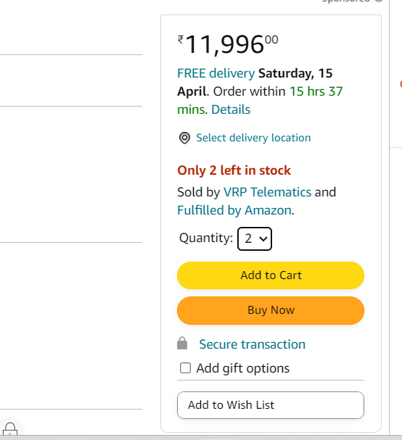

**Q.NO : 2**

**TASK 1 : SEARCH ANY PRODUCT AND DISPLAY THEM**

**CODE :**

**package** com.selenium.test2.selenium1;

**import** java.util.List;

**import** org.openqa.selenium.By;

**import** org.openqa.selenium.JavascriptExecutor;

**import** org.openqa.selenium.Keys;

**import** org.openqa.selenium.WebDriver;

**import** org.openqa.selenium.WebElement;

**import** org.openqa.selenium.chrome.ChromeDriver;

**import** org.openqa.selenium.chrome.ChromeOptions;

**import** io.github.bonigarcia.wdm.WebDriverManager;

**public** **class** CA1_Q2_2

{

**public** **static** **void** main( String[] args ) **throws** InterruptedException

{

WebDriverManager.*chromedriver*().setup();

ChromeOptions co=**new** ChromeOptions();

co.addArguments("--remote-allow-origins=*");

WebDriver driver=**new** ChromeDriver(co);

driver.get("https://www.amazon.in/");

driver.manage().window().maximize();

String actualTitle=driver.getTitle();

System.***out***.println("Page title is : " + driver.getTitle());

String expectedTitle = "Online Shopping site in India: Shop Online for Mobiles, Books, Watches, Shoes and More - Amazon.in";

**if**(actualTitle.equalsIgnoreCase(expectedTitle))

System.***out***.println("Title Matched");

**else**

System.***out***.println("Title didn't match");

WebElement txt1=driver.findElement(By.*id*("twotabsearchtextbox"));

txt1.sendKeys("Watch");

driver.findElement(By.*id*("twotabsearchtextbox")).sendKeys(Keys.***ENTER***);

JavascriptExecutor js=(JavascriptExecutor) driver;

js.executeScript("window.scrollBy(0,1000)","");

List<WebElement> l1=driver.findElements(By.*xpath*("//h5[@class='s-line-clamp-1']"));

**for**(WebElement link:l1)

{

System.***out***.println(link.getText());

}

js.executeScript("window.scrollBy(0,1000)","");

List<WebElement> l2=driver.findElements(By.*xpath*("//h5[@class='s-line-clamp-1']"));

**for**(WebElement link:l2)

{

System.***out***.println(link.getText());

}

}

}

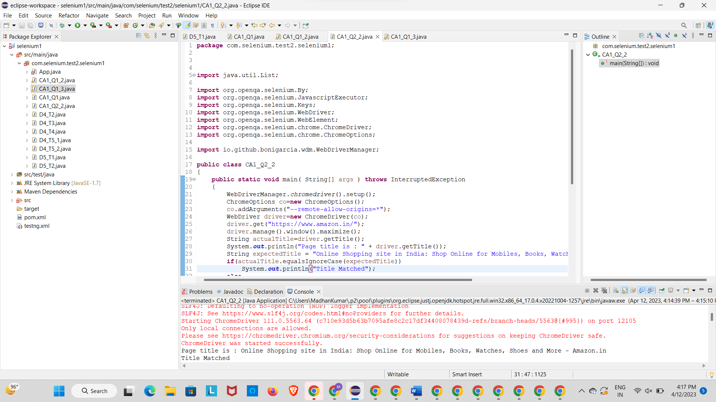

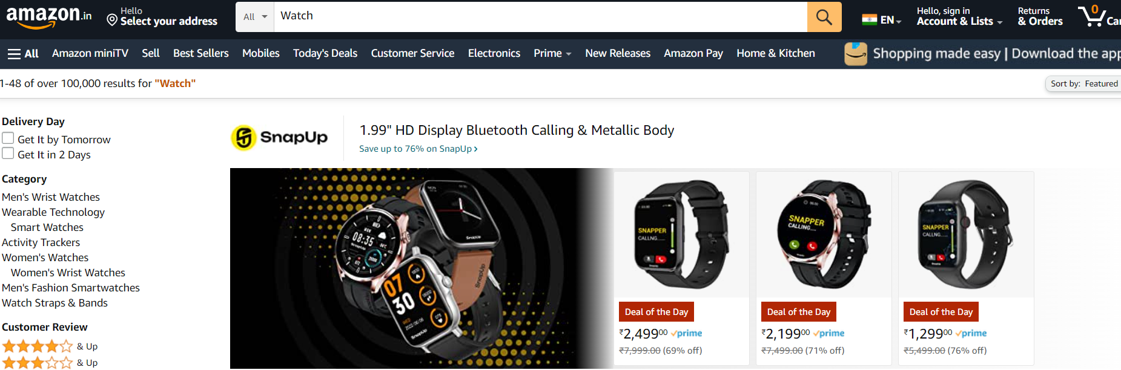

**TASK 2 : SHOW 5 PRODUCTS**

**CODE :**

**package** com.selenium.test2.selenium1;

**import** java.util.List;

**import** org.openqa.selenium.By;

**import** org.openqa.selenium.JavascriptExecutor;

**import** org.openqa.selenium.Keys;

**import** org.openqa.selenium.WebDriver;

**import** org.openqa.selenium.WebElement;

**import** org.openqa.selenium.chrome.ChromeDriver;

**import** org.openqa.selenium.chrome.ChromeOptions;

**import** io.github.bonigarcia.wdm.WebDriverManager;

**public** **class** CA1_Q2_2

{

**public** **static** **void** main( String[] args ) **throws** InterruptedException

{

WebDriverManager.*chromedriver*().setup();

ChromeOptions co=**new** ChromeOptions();

co.addArguments("--remote-allow-origins=*");

WebDriver driver=**new** ChromeDriver(co);

driver.get("https://www.amazon.in/");

driver.manage().window().maximize();

String actualTitle=driver.getTitle();

System.***out***.println("Page title is : " + driver.getTitle());

String expectedTitle = "Online Shopping site in India: Shop Online for Mobiles, Books, Watches, Shoes and More - Amazon.in";

**if**(actualTitle.equalsIgnoreCase(expectedTitle))

System.***out***.println("Title Matched");

**else**

System.***out***.println("Title didn't match");

WebElement txt1=driver.findElement(By.*id*("twotabsearchtextbox"));

txt1.sendKeys("Watch");

driver.findElement(By.*id*("twotabsearchtextbox")).sendKeys(Keys.***ENTER***);

JavascriptExecutor js=(JavascriptExecutor) driver;

js.executeScript("window.scrollBy(0,1000)","");

List<WebElement> l1=driver.findElements(By.*xpath*("//h5[@class='s-line-clamp-1']"));

**for**(WebElement link:l1)

{

System.***out***.println(link.getText());

}

js.executeScript("window.scrollBy(0,1000)","");

List<WebElement> l2=driver.findElements(By.*xpath*("//h5[@class='s-line-clamp-1']"));

**for**(WebElement link:l2)

{

System.***out***.println(link.getText());

}

}

}

